JOB DESCRIPTION
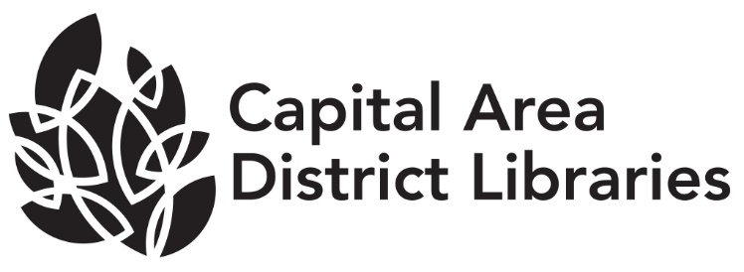
Position: MelCat/Technical Services Assistant
Range: T4 (Non-Exempt) (Union)
Reports to: Associate Director of Collection Services
Supervises: None
Reviewed: 04/2019

JOB SUMMARY
Under the direction of Associate Director of Collection Services, is responsible for MEL CAT administrative tasks and reports. Assist Selection Specialists with readers advisory and collection maintenance. Also performs cataloging and processing support for the Technical Services Department.

DUTIES AND RESPONSIBILITIES
- Responsible for sending and replying to MelCat reports. Acts as the MelCat contact for the Capital Area District Libraries. Resolves issues for CADL staff and other MelCat libraries. Is responsible for resolving helpdesk tickets related to MelCat.

- Assists Selection Specialists with collection maintenance and readers advisory tasks including compiling recommended reading lists and checking on format availability.

- Assists Youth Services Specialist with summer reading administration including prize sorting and Beanstack maintenance.

- Assists Youth Services Specialist with outreach and committee work as needed.

- Places holds on purchase suggestions and communicates with patrons.

- Provides support to Selection Specialists on preparing and inspecting, shipping, and receiving of kits for programming and circulation.

- Processes new materials for circulation including electronically attaching items to appropriate bibliographic records.

- Completes incoming Overdrive catalog records for eBooks and eaudio titles.

- Repairs damaged AV items.

- Monitors undeliverable circulation emails and corrects errors as needed. Communicates with branches to acquire valid email addresses.

- Performs other duties as assigned, including assisting other departments within Technical Services.

The above statements are intended to describe the general nature and level of work being performed by people assigned this classification. They are not to be construed as an exhaustive list of all job duties performed by personnel so classified.

JOB REQUIREMENTS

- Possession of a Bachelor’s Degree or its equivalent.

- This is an entry-level classification. No specific prior experience is required. Experience working in a public library is preferred.

- Experience with MelCat and/or using Sierra, SkyRiver or other automated cataloging system highly desirable.

- Experience or knowledge of libraries and library cataloging highly desirable.

- Successful completion of a six-month probationary period.

- Be physically able to perform the essential functions of the position, with or without reasonable accommodation.

- Ability to use computers and to utilize computer databases.

- Effective written and oral communication skills.

- Ability to establish and maintain effective working relationships with co-workers.

- Ability to conduct oneself with tact and courtesy.

